Date:15-10-26
CO1 ASSESMENT TOOL 3
CODING CHALLENGE
Name: B. Pranay Deep Chowdary
Reg No: 192472177

1.Email and Password Validator Using Regular Expressions
import re
def validate_email(email): pattern=r'^[AZaz][AZaz09._]*@[AZaz]+\.(com|org|edu|net|in)$'
if re.fullmatch(pattern, email):
print ("Valid Email")
else:
print ("Invalid Email")

def validate_password(password):
pattern =r'^(?=.*[AZ])(?=.*[az])(?=.*\d)(?=.*[@#$%&!]).{8,}$'
if re.fullmatch(pattern, password):
print ("Strong Password")
else:
print ("Weak Password")

def validate_mobile(mobile):
pattern = r'^[6-9]\d{9}$'
if re.fullmatch(pattern, mobile):
print ("Valid Mobile Number")
else:
print ("Invalid Mobile Number")

email = input ("Enter Email: ")
password = input ("Enter Password: ")
mobile = input ("Enter Mobile Number: ")

validate_email(email)
validate_password(password)
validate_mobile(mobile)
Output:
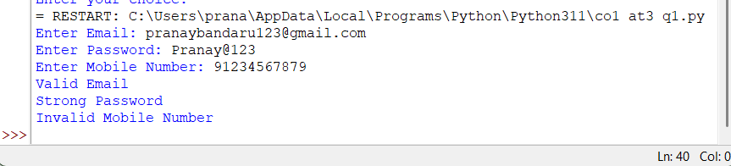

2. Finite State Automata
states = ["q0", "q1", "q2"]
alphabet = ["a", "b"]
trans = {"q0": {"a": "q1", "b": "q0"},
"q1": {"a": "q1", "b": "q2"},
"q2": {"a": "q1", "b": "q0"}}
n = int (input ("Number of strings: "))
for i in range(n):
s = input ("Enter string: ")
state, path, valid = "q0", ["q0"], True
for ch in s:
if ch not in alphabet:
valid = False
break
state = trans[state][ch]
path.append(state)

print ("Path:", " -> ".join(path))
print ("Accepted" if valid and state == "q2" else "Rejected")
OUTPUT:
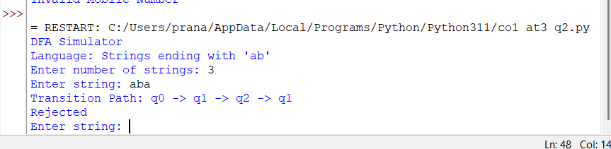
3.Smart Pattern Matching Engine using Regular Expressions
import re
text = """Meeting on 12/09/2026
Call 9876543210
#NLP
@OpenAI
natural language processing"""

def search_pattern(choice):
if choice == 1:
pattern = r'\b\d{2}/\d{2}/\d{4}\b'
name = "Dates"

elif choice == 2:
pattern = r'\b[6-9]\d{9}\b'
name = "Phone Numbers"

elif choice == 3:
pattern = r'(?<!\w)#[A-Za-z0-9_]+'
name = "Hashtags"

elif choice == 4:
pattern = r'(?<!\w)@[A-Za-z0-9_]+'
name = "Mentions"

elif choice == 5:
prefix = input ("Enter prefix: ")
pattern = r'\b' + re.escape(prefix) + r'\w*'
name = "Prefix Matches"

elif choice == 6:
suffix = input ("Enter suffix: ")
pattern = r'\b\w*' + re.escape(suffix) + r'\b'
name = "Suffix Matches"

elif choice == 7:
word = input ("Enter word to search: ")
pattern = r'\b' + re.escape(word) + r'\b'
name = "Word Matches"

else:
print ("Invalid choice")
return

matches = re.findall(pattern, text, re.IGNORECASE)

print (name + ":")
if matches:
for match in matches:
print(match)
else:
print ("No matches found")

while True:
print ("\nSMART PATTERN MATCHING ENGINE")
print ("1. Search Date")
print ("2. Search Phone Number")
print ("3. Search Hashtag")
print ("4. Search Mention")
print ("5. Search Prefix")
print ("6. Search Suffix")
print ("7. Search Word")
print ("8. Exit")

choice = int (input ("Enter your choice: "))

if choice == 8:
print ("Exiting program")
break
search_pattern(choice)

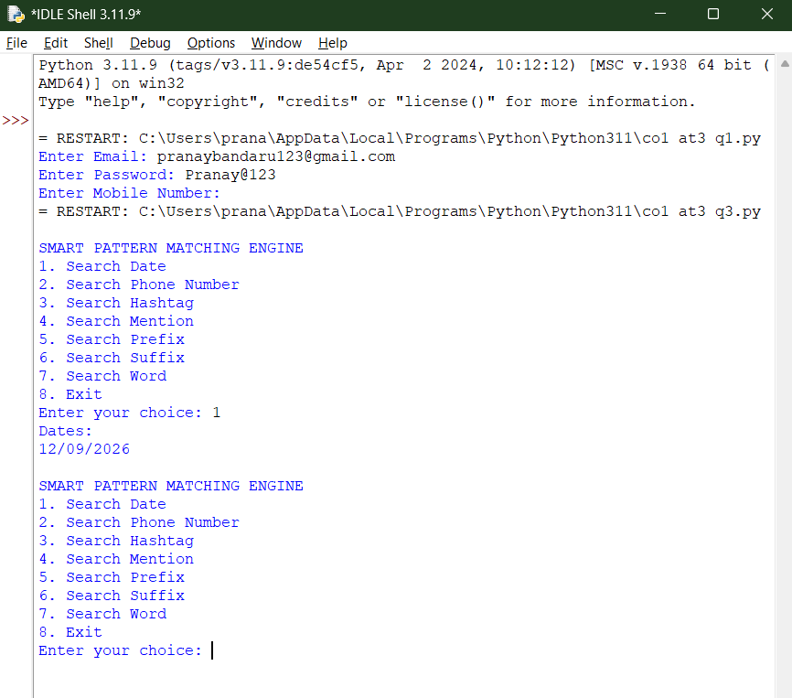
Output:

